Individual assignment

For this submission, you must do the following:

* Join Jira Board
* Do some research of making a mobile app from a web app
* Get a device to code swift on
* Draw up a design for the iOS app

For each task, link the commit or commits that completes the task

Explain how you can verify that the tasks you were assigned were completed

Screenshots of Jira Board

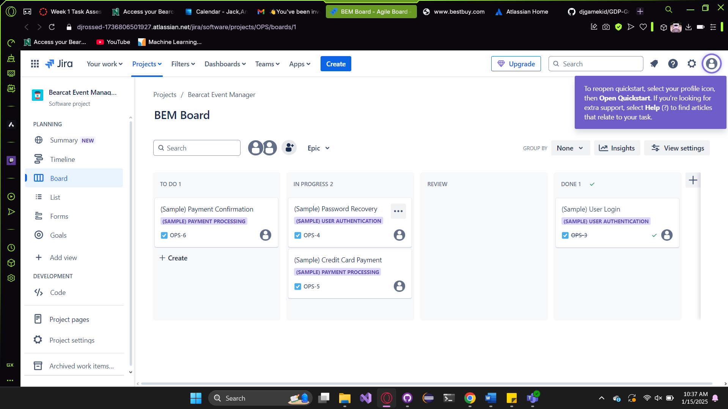

Links to the different sites that I researched

<https://ax3l.medium.com/how-to-build-an-android-app-an-ios-app-and-a-web-app-with-react-native-5cad1454b0b8>

<https://ionic.io/resources/articles/converting-websites-into-mobile-apps>

The receipt of the macbook

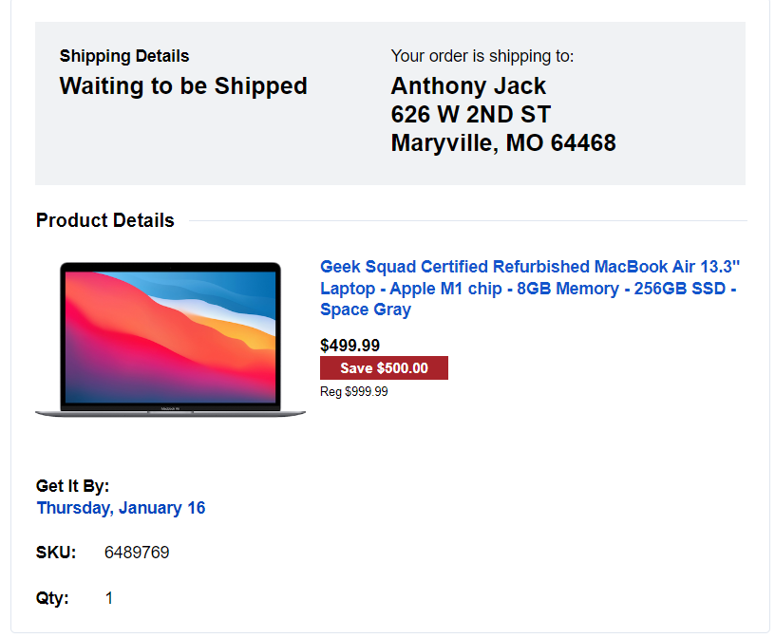

Rough Drafts pictures from the notebook

See pdf in folder on git hub

Task must match the requirement of designed software documents. (Software environment setup usually not considered as part of this point, but no deduction applied).